Australian Volunteer Program – Profile

My name is Molly Elliot. I have been working as a Prosecution Mentor within the Office of the Director of Public Prosecutions (ODPP) based in Gizo, Western Province.

Before arriving in the Solomon Islands 10 months ago I was working in a private law firm in North Queensland as a family and criminal lawyer. My role now is as a Prosecutions Mentor within the Office of the Director of Public Prosecutions (ODPP). Unlike most volunteers, I am not based in the capital of Honiara, but rather in Gizo, in the Western Province. The ODPP office in Gizo consists of only one local prosecutor, so my role is to work one-on-one with my colleague to increase his capacity to effectively prosecute crime in the Magistrates and High Courts. My assignment has largely focused on case management as there are limited resources and many delays, meaning cases need to be properly managed to ensure they progress through the justice system in a timely manner.

The work is varied, however, a typical day often involves attending court mentions with my local colleague and then working to prepare cases back in the office. Some days also include providing advice to Police with respect to new investigations, working on improving office management systems, and providing training sessions with my local colleague.

My work is benefitting the ODPP by providing ground level support to a local prosecutor. I hope that at the conclusion of my time here, my local colleague will have gained skills and developed tools to better manage cases. This will in turn benefit the broader community of Solomon Islands by providing better access to justice.

Whilst this is my first experience volunteering outside of Australia, both my older sisters completed AVI assignments in the Pacific, so I felt very prepared for what to expect. I volunteer regularly at home, including at my local Community Legal Centre, but had always wanted to volunteer overseas. This position was the perfect opportunity as it has allowed me to develop both professionally and personally.

One of my favourite memories will be traveling for Court Circuits. This provided me with an amazing opportunity to work with locals from other justice sector organisations, including the Magistrates Court, Police, Police Prosecutions and Public Solicitors Office. It also allowed me to engage with local communities across the Western and Choiseul Provinces.

Living in the Solomon Islands has been as rewarding an experience as volunteering itself. Upon my arrival in Gizo, the locals immediately made me feel part of the community and helped me to master the local pijin language. It is not possible to walk to the local market without stopping to “story” (chat) with someone. I have been fortunate enough to attend a local wedding, shared a Christmas lunch of fish on a nearby-uninhabited island with a local family and also been a special guest at a festival. The country itself is also a natural wonder – pristine waters for snorkeling and beautiful rainforests for hiking are all on my doorstep.

As beautiful as the Solomon Islands is, its people have been the highlight of my time here. Therefore, having the opportunity to share my knowledge and experience with those I work with, and seeing those new skills being applied, has been the most rewarding part of my experience. Leana Hola!

Molly’s assignment is funded by the Australian Government through the Australian Volunteers Program managed in Solomon Islands by AVI. Each year up to 46 new volunteers arrive in Solomon Islands to take up their assignments in various sectors as part of the program.

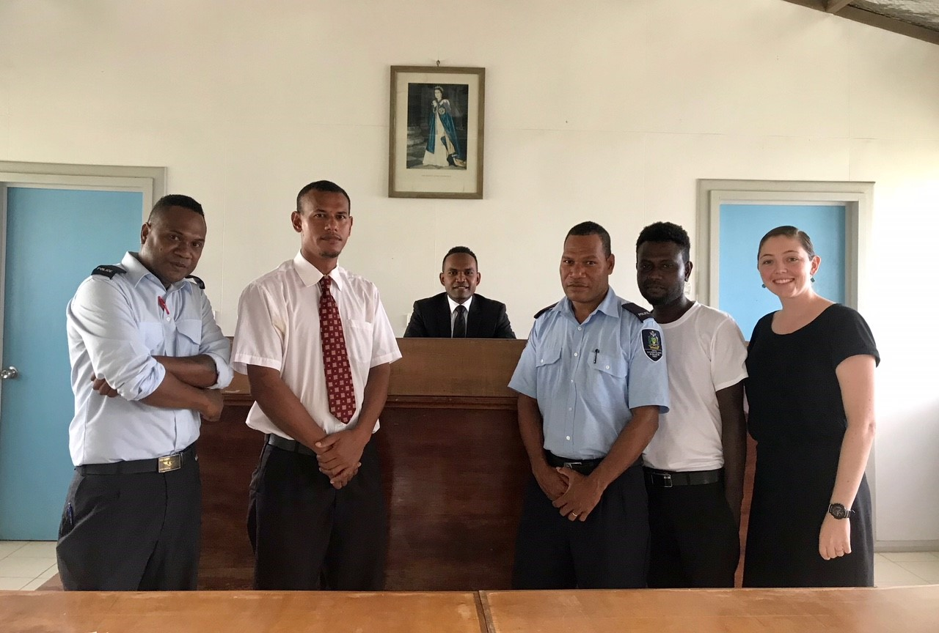
PC Terrence Vildam, ODPP Senior Legal Officer Ishmael Kekou, Principal Magistrate Leonard Chite, PC Ronnie Pisei, Magistrates Court Criminal Clerk Sam Tatapu and Molly in the Magistrates Court at Gizo.

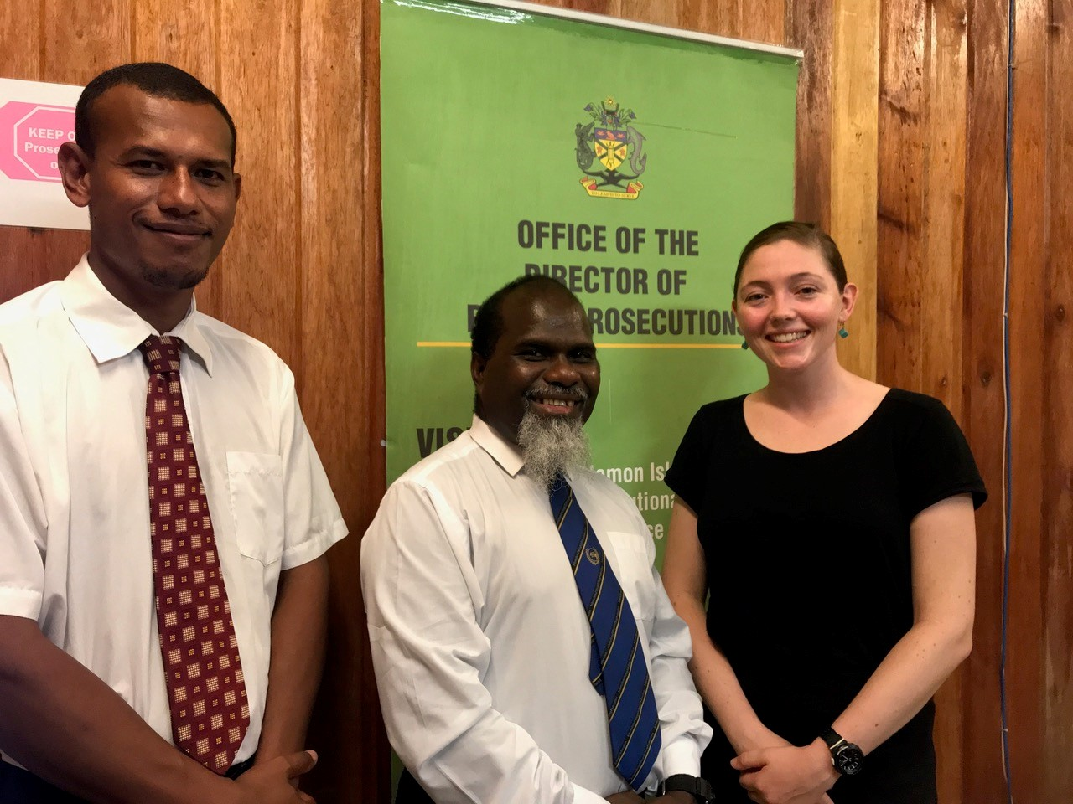
ODPP Senior Legal Officer Ishmael Kekou Ishmael Kekou, the Director of Public Prosecutions of the Solomon Islands Mr Ronald Talasasa and Molly in the ODPP office in Gizo.

